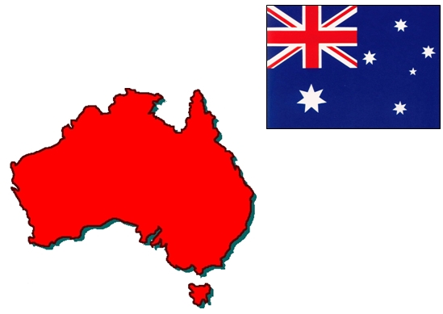 | 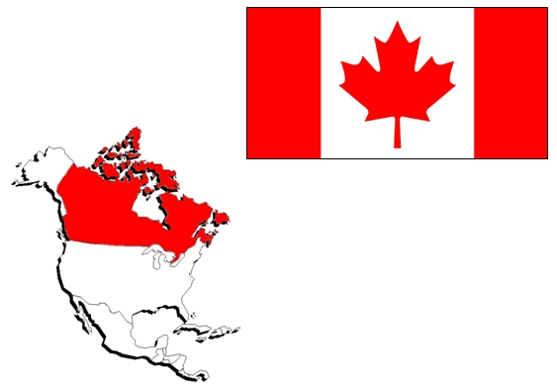 | 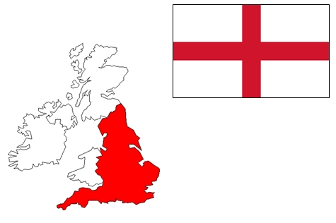 | 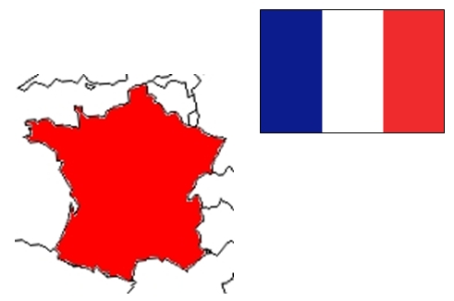 | 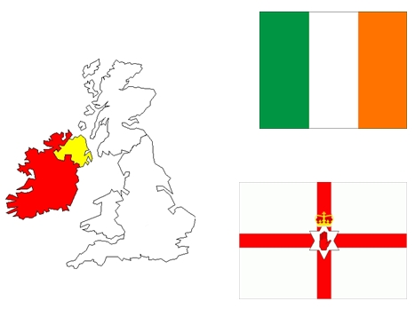 | 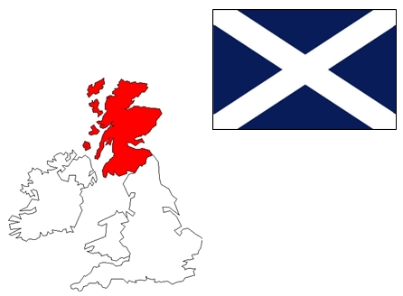
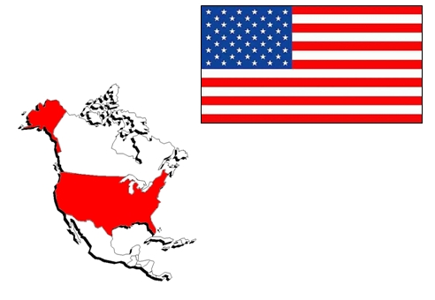 | 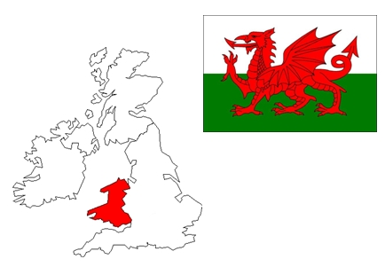 | 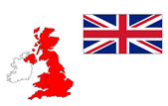

Australia | Canada | England | France | Ireland | Scotland
United States of America  USA | Wales | United Kingdom
Australia | Canada | England | France | Ireland | Scotland
United States of America  USA | Wales | United Kingdom
Australia | Canada | England | France | Ireland | Scotland
United States of America  USA | Wales | United Kingdom

Australian | Canadian | English | French | Irish | Scottish
American | Welsh | British
Australian | Canadian | English | French | Irish | Scottish
American | Welsh | British
Australian | Canadian | English | French | Irish | Scottish
American | Welsh | British

