Anglais - Les parties du corps 1

Listen and color the body parts.

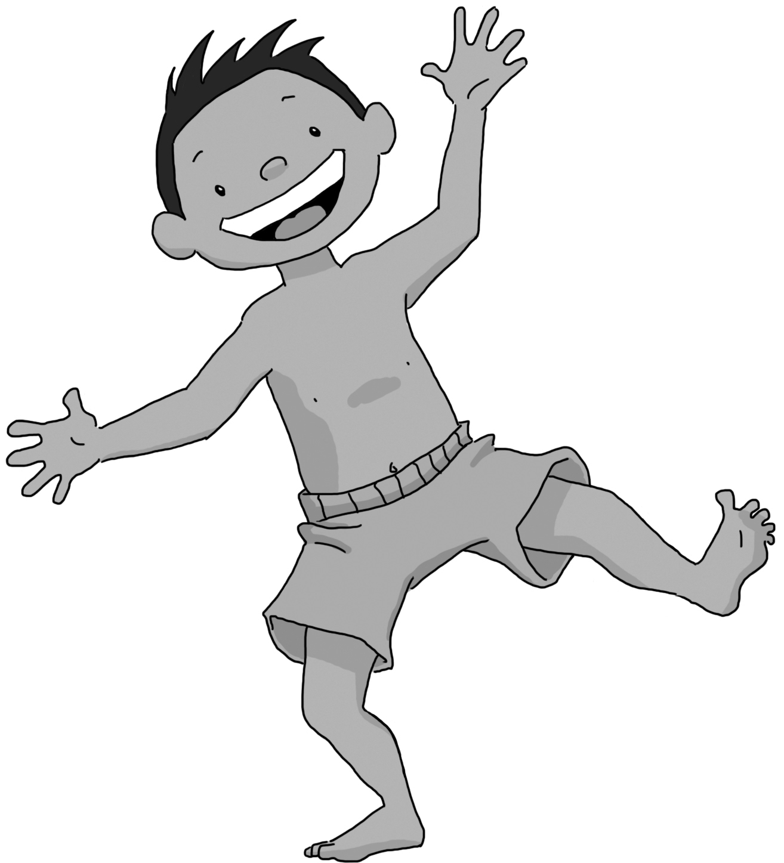

Anglais - Les parties du corps 1 Corrigé

Listen and color the body parts.

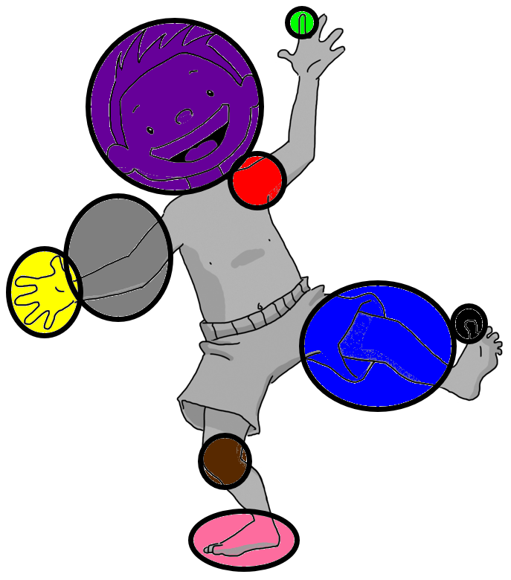
Anglais - Les parties du corps 2

Write the words in the crossword.

 |  |  |  |  |  |  | 2 |  |  |  | 1 | 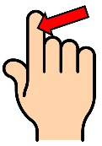 | 2 | 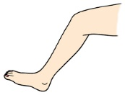
 |  |  |  |  |  |  |  |  | 7
 |  |  |  | 3 |  |  |  |  |  |  | 3 | 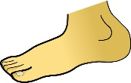 | 4
 |  |  | 1
 |  |  |  |  |  | 5 |  |  |  |  | 5 | 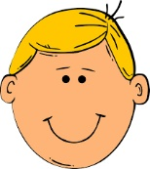 | 6 | 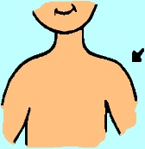
 |  |  | 4 |  |  |  |  |  |  |  | 7 | 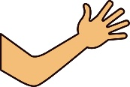 | 8 | 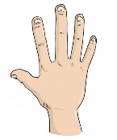
 |  | 8
6 |  |  |  |  |  |  |  |  |  |  | 9 | 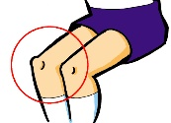
9

Anglais - Les parties du corps 2

Write the words in the crossword.

 |  |  |  |  |  |  | 2 |  |  |  | 1 |  | 2
 |  |  |  |  |  |  |  |  | 7
 |  |  |  | 3 |  |  |  |  |  |  | 3 |  | 4
 |  |  | 1
 |  |  |  |  |  | 5 |  |  |  |  | 5 |  | 6
 |  |  | 4 |  |  |  |  |  |  |  | 7 |  | 8
 |  | 8
6 |  |  |  |  |  |  |  |  |  |  | 9
9

Anglais - Les parties du corps 2 Corrigé

Write the words in the crossword.

 |  |  |  |  |  |  | 2 |  |  |  | 1 |  | 2
 |  |  |  |  |  |  | L |  | 7
 |  |  |  | 3 |  |  | E |  | A |  | 3 |  | 4
 |  |  | 1 | F | I | N | G | E | R
 |  |  |  | O |  | 5 |  |  | M |  | 5 |  | 6
 |  |  |  | O |  | H
 |  |  | 4 | T | O | E |  |  |  |  | 7 |  | 8
 |  | 8 |  |  |  | A
6 | S | H | O | U | L | D | E | R |  |  | 9
 |  | A
9 | K | N | E | E
 |  | D

Anglais - Les parties du corps 3

Complete the picture with the words.

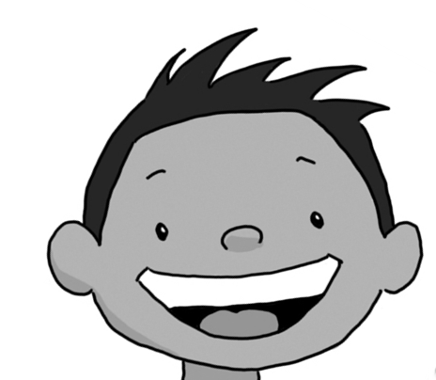

Anglais - Les parties du corps 3

Complete the picture with the words.

Anglais - Les parties du corps 3 Corrigé

Complete the picture with the words.
hair

mouth

eye

nose
ear

Anglais - Les parties du corps 4

Listen to the song, stick the pictures and write the words.

 |  | __________________ , __________________ , __________________ and __________________ . | x 2
 |  | __________________ and __________________ .
And __________________ and __________________
and __________________ and __________________ .
 |  | __________________ , __________________ , __________________ and __________________ .
 |  | __________________ and __________________ .

 |  | 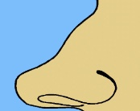 | 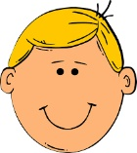 | 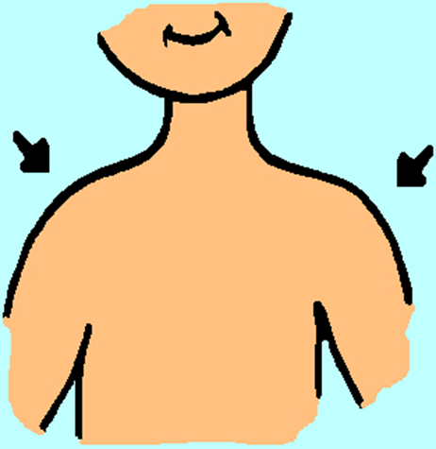 |  |  | 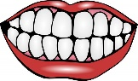

Anglais - Les parties du corps 4 Corrigé

Listen to the song, stick the pictures and write the words.

 |  | Head, shoulders,  knees and toes. | x 2
 |  | knees and toes.
And eyes and ears
and mouth and nose.
Head, shoulders,
knees and toes.
 |  | knees and toes.

