Anglais - La ville 1

Listen and number the pictures.
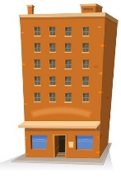

Anglais - La ville 1

Listen and number the pictures.

Anglais - La ville 1

Listen and number the pictures.

Anglais - La ville 1 Corrigé

Listen and number the pictures.
3 | 5 | 10 | 1 | 7
4 | 9 | 2 | 8 | 6

Anglais - La ville 2

Listen and draw crosses where people are going.

1
Mark
Suzy
Adriana

2
Hilary
Tom
William

Anglais - La ville 2 Corrigé

Listen and draw crosses where people are going.

1
Mark |  | X |  | X
Suzy |  | X | X | X
Adriana | X |  | X

2
Hilary | X
Tom |  |  | X | X
William |  | X | X

Anglais - La ville 3

1 - Find and circle the words.

E | M | U | S | E | U | M | S
T | C | F | P | A | R | K | C
L | I | B | R | A | R | Y | H
V | T | T | R | E | S | O | O
C | Y | S | T | O | R | E | O
H | O | S | P | I | T | A | L
E | S | A | H | O | U | S | E
B | U | I | L | D | I | N | G

2 - Look at the pictures and write the sentences.

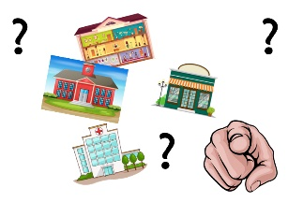
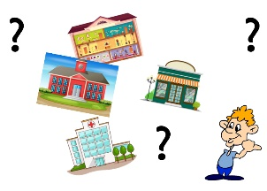

Anglais - La ville 3 Corrigé

1 - Find and circle the words.

E | M | U | S | E | U | M | S
T | C | F | P | A | R | K | C
L | I | B | R | A | R | Y | H
V | T | T | R | E | S | O | O
C | Y | S | T | O | R | E | O
H | O | S | P | I | T | A | L
E | S | A | H | O | U | S | E
B | U | I | L | D | I | N | G

2 - Look at the pictures and write the sentences.

Where are you going ?
I’m going to the museum.
Where is he going ?
Where is she going ?
He’s going to the store.
She’s going to the store.
He’s going to the swimming pool.
She’s going to the swimming pool.

Anglais - La ville 4

Listen and write the sentences.

Anglais - La ville 4

Listen and write the sentences.

Anglais - La ville 4 Corrigé

Listen and write the sentences.

Where are you going ?
I’m going to the hospital.
Where is she going ?
She’s going to the library.
Where is he going ?
He’s going to the park.

