Anglais - Halloween 1

Listen to the song, stick the pictures and write the words.

Halloween colours
Black ........................
Orange ....................................
White .......................................
Green-eyed ..................................
............................. , ............................. , ............................. , ............................. .
These are the colours of Halloween !
Black .......................
...................es’ .................
Jack’o lanterns, Jack’o lanterns,
............................. , ............................. , ............................. , ............................. .
These are the colours of Halloween !

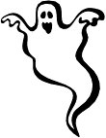 | 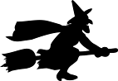 | 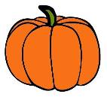 | 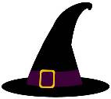 | 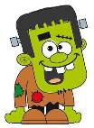 | 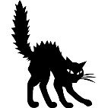
Anglais - Halloween 1 Corrigé

Listen to the song, stick the pictures and write the words.

Halloween colours
Black cat
Orange pumpkin
White ghost
Green-eyed monster
Black, orange,
white, green.
These are the colours of Halloween !
Black cats
Witches’ hats
Jack’o lanterns, Jack’o lanterns,
Black, orange,
white, green.
These are the colours of Halloween !

Anglais - Halloween 1  Halloween colours  Black cat,  Orange pumpkin,  White ghost,  Green-eyed monster.  Black, orange, white, green,  These are the colours of Halloween !  Black cats  Witches’ hats,  Jack o’lanterns,  Jack o’lanterns.  Black, orange, white, green,  These are the colours of Halloween ! | Anglais - Halloween 1  Halloween colours  Black cat,  Orange pumpkin,  White ghost,  Green-eyed monster.  Black, orange, white, green,  These are the colours of Halloween !  Black cats  Witches’ hats,  Jack o’lanterns,  Jack o’lanterns.  Black, orange, white, green,  These are the colours of Halloween !
Anglais - Halloween 1  Halloween colours  Black cat,  Orange pumpkin,  White ghost,  Green-eyed monster.  Black, orange, white, green,  These are the colours of Halloween !  Black cats  Witches’ hats,  Jack o’lanterns,  Jack o’lanterns.  Black, orange, white, green,  These are the colours of Halloween ! | Anglais - Halloween 1  Halloween colours  Black cat,  Orange pumpkin,  White ghost,  Green-eyed monster.  Black, orange, white, green,  These are the colours of Halloween !  Black cats  Witches’ hats,  Jack o’lanterns,  Jack o’lanterns.  Black, orange, white, green,  These are the colours of Halloween !

Anglais - Halloween 2

Write the words.
 |  |  |  |  |  | 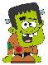
 |  |  |  |  |  |  |  |  |  |  |  |  | 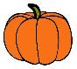
 |  |  | 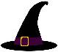 |  | 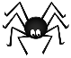
 | 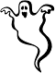
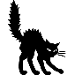
 |  |  |  |  | 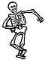

Anglais - Halloween 2 Corrigé

Write the words.
 |  |  |  |  |  | M
 |  |  |  |  |  | O
 |  |  |  |  |  | N |  | W |  |  | T
 |  |  |  |  |  | S | P | I | D | E | R |  | P
 |  | G | H | O | S | T |  | T |  |  | I |  | U
 |  |  | A |  |  | E |  | C |  |  | C |  | M
 | C | A | T |  |  | R |  | H |  |  | K |  | P
 |  |  |  |  |  |  |  |  |  |  | O |  | K
 |  |  |  |  |  |  |  |  |  |  | R |  | I
 |  |  |  |  |  | S | K | E | L | E | T | O | N
 |  |  |  |  |  |  |  |  |  |  | R
 |  |  |  |  |  |  |  |  |  |  | E
 |  |  |  |  |  |  |  |  |  |  | A
 |  |  |  |  |  |  |  |  | B | A | T

