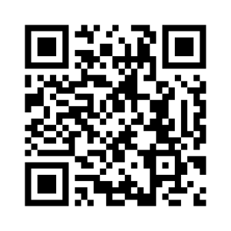**ANG 4 Les sentiments et les sensations**

|  |  |
| --- | --- |
|  | ***Je sais ma leçon si…*** |
| ***ANG 4*** | ➊ *Je sais demander à quelqu’un comment il se sent.* |
| ➋ *Je sais dire comment je me sens.* |

|  |  |
| --- | --- |
|  | Fine |
|  | Happy |
|  | Sad |
|  | Angry |
|  | Scared |
|  | Hot |
|  | Cold |
|  | Ill |
|  | Hungry |
|  | Thirsty |
|  | Tired |
|  | How are you ? |
|  | Are you… ? |
|  | I am… |
|  | Yes, I am. |
|  | No, I’m not. |