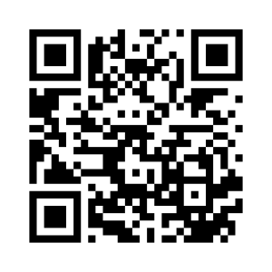**ANG 4 Ce que l’on sait faire**

|  |  |
| --- | --- |
|  | ***Je sais ma leçon si…*** |
| ***ANG 4*** | ➊ *Je sais dire ce que je sais faire.* |
| *➋ Je sais demander à quelqu’un ce qu’il sait faire.* |
| ➌ *Je sais répondre par une réponse courte.* |

|  |  |
| --- | --- |
| Dance | dance |
| Draw | draw |
| Play rugby | play rugby |
| Play soccer | play football (soccer) |
| Play the drums | play the drums |
| Play the guitar | play the guitar |
| Play the piano | play the piano |
| Ride a horse | ride a horse |
| Sing | sing |
| Swim | swim |
| I can | I can… |
|  | I can’t… |
| Can you | Can you… ? |
| Yes I can | Yes, I can. |
| No I can't | No, I can’t. |